Section I: Scenario Demographics

Scenario Title: | Ruptured Ectopic
Date of Development: | 27/05/2015 (DD/MM/YYYY)
Target Learning Group: | Juniors (PGY 1 – 2) Seniors (PGY ≥ 3) All Groups

Section II: Scenario Developers

Scenario Developer(s): | Kyla Caners
Affiliations/Institution(s): | McMaster University
Contact E-mail (optional): | kcaners@gmail.com

Section III: Curriculum Integration

Learning Goals & Objectives
Educational Goal: | To ensure that learners can appropriately resuscitate a patient with intra-peritoneal bleeding.
CRM Objectives: | Effectively lead team members through complex critical scenario.
Medical Objectives: | - Recognize potential ruptured ectopic and initiate resuscitation, workup, and consultation.  - Administer massive transfusion in appropriate blood product ratio using adjuncts to increase speed of delivery (e.g. –pressure bag, level one).  - Demonstrate a broad approach to the initial management and workup of a patient presenting with syncope and hypotension

Case Summary: Brief Summary of Case Progression and Major Events
26 year-old female, recently immigrated from Cambodia, presents after a syncopal episode at home. At the case outset, she complains of feeling “a little dizzy” and has a HR of 100 and a BP of 90/60. Once the team initiates care, the patient will say she has to vomit and then become poorly responsive and more hypotensive. The patient does not know that she is pregnant, so the team will have to consider the diagnosis early and use bedside U/S to point them in the right direction. The team will then need to initiate a massive transfusion and arrange for surgery. If the ectopic pregnancy is not recognized, the patient will become persistently more hypotensive until she has a PEA arrest.

References
Marx, J. A., Hockberger, R. S., Walls, R. M., & Adams, J. (2013). Rosen’s emergency medicine: Concepts and clinical practice. St. Louis: Mosby.
Massive transfusion: http://lifeinthefastlane.com/trauma-tribulation-026/

Section IV: Scenario Script

A. Scenario Cast & Realism
Patient: | Computerized Mannequin |  |  |  |  | Realism:  Select most important dimension(s) |  |  | Conceptual
 | Mannequin |  |  |  |  |  |  |  | Physical
 | Standardized Patient |  |  |  |  |  |  |  | Emotional/Experiential
 | Hybrid |  |  |  |  |  |  |  | Other:
 | Task Trainer |  |  |  |  |  |  |  | N/A
Confederates | Brief Description of Role
None.
B. Required Monitors
EKG Leads/Wires |  |  | Temperature Probe |  |  |  | Central Venous Line
NIBP Cuff |  |  | Defibrillator Pads |  |  |  | Capnography
Pulse Oximeter |  |  | Arterial Line |  |  |  | Other:
C. Required Equipment
Gloves |  |  | Nasal Prongs |  |  |  | Scalpel
Stethoscope |  |  | Venturi Mask |  |  |  | Tube Thoracostomy Kit
Defibrillator |  |  | Non-Rebreather Mask |  |  |  | Cricothyroidotomy Kit
IV Bags/Lines |  |  | Bag Valve Mask |  |  |  | Thoracotomy Kit
IV Push Medications |  |  | Laryngoscope |  |  |  | Central Line Kit
PO Tabs |  |  | Video Assisted Laryngoscope |  |  |  | Arterial Line Kit
Blood Products |  |  | ET Tubes |  |  |  | Other:
Intraosseous Set-up |  |  | LMA |  |  |  | Other:
D. Moulage
None required.

E. Approximate Timing
Set-Up: |  | 3 min |  | Scenario: | 12 min |  |  | Debriefing: |  | 15 min

Section V: Patient Data and Baseline State

A. Clinical Vignette: To Read Aloud at Beginning of Case
26 year old female presents after a syncopal episode at home. She immigrated from Cambodia two weeks ago to work as a live-in nanny, but has been feeling unwell for the last 3 days. The patient speaks limited English, but the family she is staying with said she has been vomiting the past few days and was unable to get out of bed this morning. When she tried, she because quite dizzy and then passed out.

B. Patient Profile and History
Patient Name: Mindy Loewen |  |  |  |  |  | Age: 26 |  |  |  |  |  |  |  | Weight: 70kg
Gender: M F |  |  |  |  |  | Code Status: Full
Chief Complaint: Syncope
History of Presenting Illness: Feeling unwell for 3 days. Vomiting and unable to get out of bed this morning. When she tried, she became dizzy and passed out.
Past Medical History: |  | None. |  |  |  |  | Medications: |  |  |  |  | Prenatal vitamins
Allergies: Shellfish
Social History: Lives with family for which she is a live-in nanny.
Family History: None significant.
Review of Systems: |  | CNS: |  |  | Feels dizzy and lightheaded. No headache.
 |  | HEENT: |  |  | No visual/speech changes.
 |  | CVS: |  |  | No palpitations.
 |  | RESP: |  |  | No SOB.
 |  | GI: |  |  | Vomiting x3 days. Vague abdominal pain.
 |  | GU: |  |  | No LUTS.
 |  | MSK: |  |  | Nil. |  |  |  |  |  |  |  | INT: |  | Nil.
C. Baseline Simulator State and Physical Exam
No Monitor Display |  |  |  | Monitor On, no data displayed |  |  |  |  |  |  | Monitor on Standard Display
HR: 100/min |  |  | BP: 90/60 |  |  |  |  | RR: 12/min |  |  |  |  |  |  | O₂SAT: 98%
Rhythm: NSR |  |  | T: 36.5ºC |  |  |  |  | Glucose: 6.3 mmol/L |  |  |  |  |  |  | GCS: 15 (E4 5V M6)
General Status: Looks pale. In no distress.
CNS: | Alert, appropriate. No focal neuro deficits.
HEENT: | PERLA. 3mm.
CVS: | No murmur
RESP: | No advent. GAEB.
ABDO: | Diffusely tender. No rebound.
GU: | Nil.
MSK: | Nil. |  |  |  |  |  |  |  | SKIN: | Pale.

Scenario States, Modifiers and Triggers
Patient State | Patient Status | Learner Actions, Modifiers & Triggers to Move to Next State
1. Baseline State  Rhythm: NSR  HR: 100/min  BP: 90/60  RR: 12/min  O₂SAT: 98%  T: 36.5ºC | Pale, but otherwise well. Alert, appropriate. | Learner Actions  - IV, monitors  - Further hx and px  - Cap sugar: 6.3  - ECG: NSR  - Urine or blood for βHCG  - Basic labs, including G+S  - IV NS 1L bolus | Modifiers  Changes to patient condition based on learner action  Triggers  For progression to next state  - 4 min 2. Syncope
2. Syncope  HR 110  BP 80/40 | Patient starts state by saying “I think I’m going to throw up.” Then is poorly responsive. (Sleepy, groans only, opens eyes to voice.) | Learner Actions  - Establish 2nd iv (if not yet)  - Bolus IVF x2  - U/S to r/o ectopic/FF  - 2u PRBC once confirm ectopic  - Call GYNE for OR  - Activate MTP  - ± Intubate for OR | Modifiers  - 6 min BP 70/35, HR 115  - 8 min BP 65/30, HR 120  - If ask for βHCG result, give back positive result  Triggers  - If free fluid not identified by 9 min 3. PEA arrest  - Free fluid identified, 4u PRBC given 4. Resolution
3. PEA Arrest  Rhythm PEA  BP -/- | Patient pulseless and unresponsive. | Learner Actions  - High quality CPR  - Epinephrine q3 min  - Transfuse PRBC/MTP  - ±Intubate | Modifiers  - If ectopic not yet ID’d, give urine βHCG saying “the nurse at triage sent it”  Triggers  - Activate MTP for presumed ectopic 4. Resolution  - 12 min 4. Resolution
4. Resolution  Rhythm Sinus tach  HR 120  BP 85/45 | Patient intubated & sedated. Stable now. (If not intubated, then awake, but sleepy.) | Learner Actions  - ±Intubate  - Call Gyne for OR  - Continue 1:1:1 transfusion | END CASE GYNE ARRIVES
Section VI: Scenario Progression

Section VII: Supporting Documents, Laboratory Results, & Multimedia

Laboratory Results
Urine βHCG result given if required.

Images (ECGs, CXRs, etc.)
ECG – NSR or sinus tach (depending on state when done)  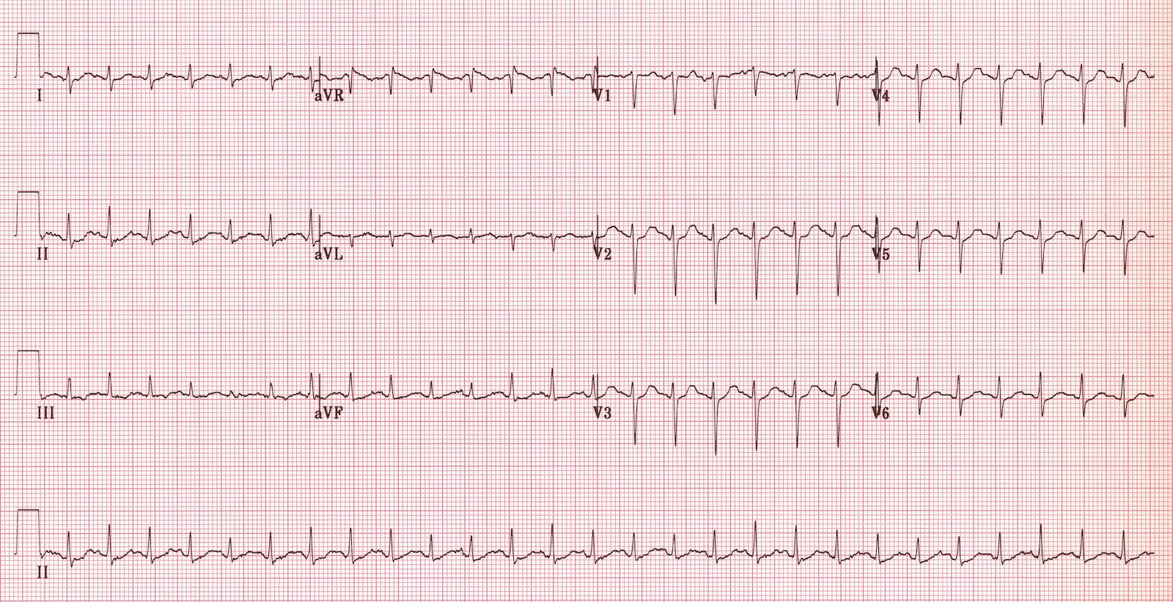  Sinus tachycardia  ECG source: http://cdn.lifeinthefastlane.com/wp-content/uploads/2011/12/sinus-tachycardia.jpg  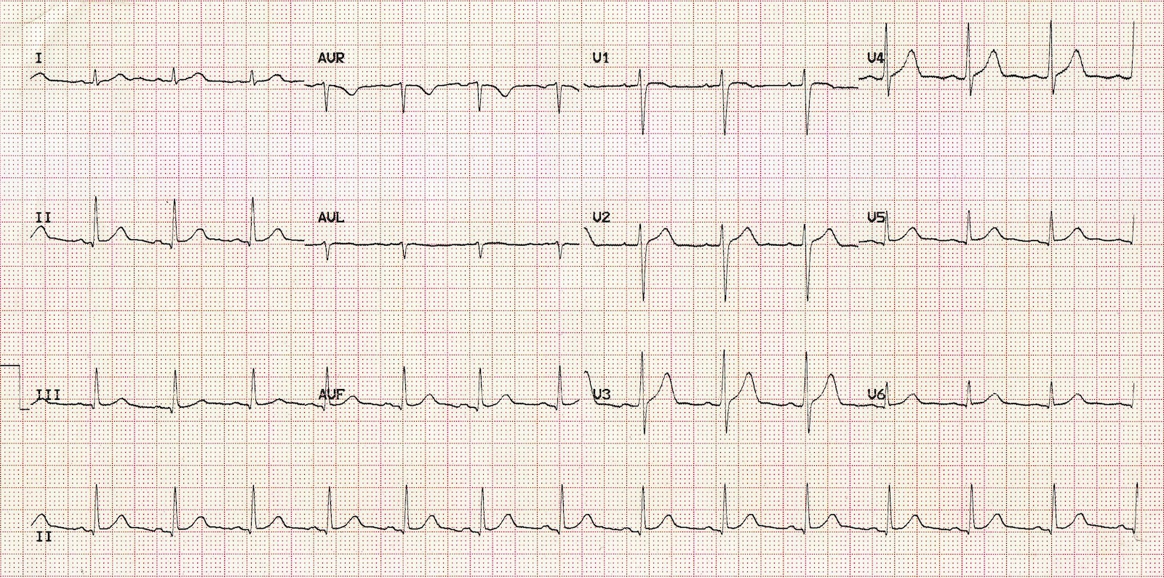  Normal sinus rhythm  ECG source: http://cdn.lifeinthefastlane.com/wp-content/uploads/2011/12/normal-sinus-rhythm.jpg | CXR – post intubation  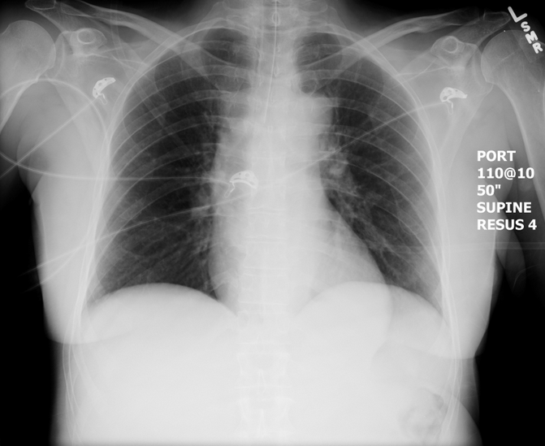  CXR source: https://emcow.files.wordpress.com/2012/11/normal-intubation2.jpg
Ultrasound Video Files (if applicable)
- FF RUQ
- No IUP (transabdominal image)

Section VIII: Debriefing Guide

General Debriefing Plan
Individual |  | Group | With Video | Without Video
Objectives
Educational Goal: | To ensure that learners can appropriately resuscitate a patient with intra-peritoneal bleeding.
CRM Objectives: | Effectively lead team members through complex critical scenario.
Medical Objectives: | - Recognize potential ruptured ectopic and initiate resuscitation, workup, and consultation.  - Administer massive transfusion in appropriate blood product ratio using adjuncts to increase speed of delivery (e.g. –pressure bag, level one).  - Demonstrate a broad approach to the initial management and workup of a patient presenting with syncope and hypotension
Sample Questions for Debriefing
- How did it feel to lead the team through a massive transfusion?
- How do you feel the team communicated about the possible diagnoses and the management plan?
- If you don’t have an official massive transfusion protocol, what is your strategy for transfusion?
- This patient’s presentation was not straightforward. How did you work towards your ultimate diagnosis? Did the team feel like they understood the team leader’s thought process?
Key Moments
Early differential diagnosis of syncope in young woman must include βHCG and ECG
Recognition of ectopic pregnancy as most likely diagnosis (and US to identify it)
Initiation of massive transfusion and early call for OR.

